The Parish Church of

St John the Baptist

Earlestown
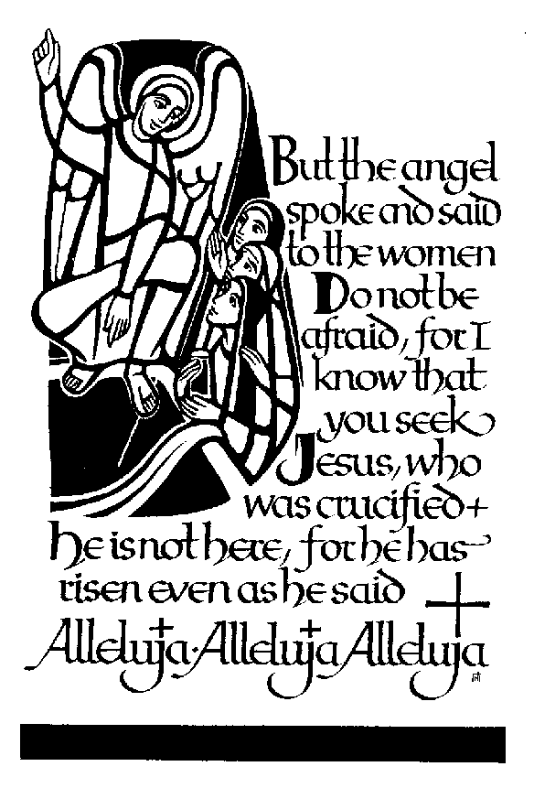

Rachel Louise Forber
1980 - 2001

I am sure that neither life nor death, nor angels, nor principalities nor powers, nor things present, nor things to come, nor height, nor depth, nor anything else in all creation can separate us from the love of God in Christ Jesus our Lord.

God’s love and power extend over all creation. Every life, including our own, is precious to God. Christians have always believed that there is hope in death as in life, and that there is new life in Christ over death.

Even those who share such faith find that there is a real sense of loss at the death of a loved one. We will each have had our own experiences of their life and death, with different memories and different feelings of love, grief and respect. To acknowledge this at the beginning of the service should help us to use this occasion to express our faith and our feelings as we say farewell, to acknowledge our loss and our sorrow, and to reflect on our own mortality. Those who mourn need support and consolation. Our presence here today is part of that continuing support.

Order of Service in Church

ALL STAND as the funeral procession enters the church. Once the family are seated, please SIT

The Vicar, the Rev David Fadugba, may read one or more scriptural sentences.

Introduction

Vicar: We meet in the name of Jesus Christ, who died and was raised to the glory of God the Father. Grace and mercy be with you.
All: Amen.

The Vicar introduces the service

Vicar: Let us pray.

Almighty God, you judge us with infinite mercy and justice, and love everything you have made. In your mercy turn the darkness of death into the dawn of new life, and the sorrow of parting into the joy of heaven; through our Saviour, Jesus Christ. Amen

Vicar: Merciful Father, hear our prayers and comfort us; renew our trust in your Son, whom you raised from the dead; strengthen our faith that all who have died in the love of Christ will share in his resurrection; who lives and reigns with you, in the unity of the Holy Spirit, one God, now and for ever. Amen

The Ministry of the Word

The Poem – a tribute to Rachel written and read by Lisa

Song (Please remain seated for the song ‘Shining down on me’)

Reading
from the Revelation of St John, chapter 21, verses 1-7, read by Shaun

The Address: the Rev. Michael Raynor

Song (Please remain seated for ‘Immortality’)

The Prayers: the Vicar

Vicar: Let us pray with confidence as our Saviour has taught us
All: Our Father, who art in heaven, hallowed be thy name; thy kingdom come; thy will be done; on earth as it is in heaven. Give us this day our daily bread. And forgive us our trespasses, as we forgive those who trespass against us. And lead us not into temptation; but deliver us from evil. For thine is the kingdom, the power and the glory, for ever and ever. Amen.

Hymn: (please stand)

Abide with me; fast falls the eventide:
the darkness deepens; Lord, with me abide:
when other helpers fail, and comforts flee,
help of the helpless, O abide with me.

I need thy presence every passing hour;
what but thy grace can foil the tempter's power?
Who like thyself my guide and stay can be?
Through cloud and sunshine, Lord, abide with me.

I fear no foe with thee at hand to bless;
ills have no weight, and tears no bitterness,
Where is death's sting? Where, grave, thy victory?
I triumph still, if thou abide with me.

Hold thou thy cross before my closing eyes;
shine through the gloom, and point me to the skies:
heaven's morning breaks, and earth's vain shadows flee;
in life, in death, O Lord, abide with me.

Commendation and Farewell [please remain standing]

Vicar: Let us commend Rachel to the mercy of God our Maker and Redeemer.

God our creator and redeemer, by your power Christ conquered death and entered into glory. Confident of his victory and claiming his promises, we entrust Rachel to your mercy in the name of Jesus our Lord, who died and is alive and reigns with you, now and for ever. Amen

All: Heavenly Father, in your Son Jesus Christ you have given us a true faith and a sure hope. Strengthen this faith and hope in us all our days, that we may live as those who believe in the communion of saints, the forgiveness of sins and the resurrection to eternal life; through Jesus Christ our Lord. Amen.

Vicar: May God, in his infinite love and mercy, bring the whole Church, living and departed in the Lord Jesus, to a joyful resurrection, and the fulfilment of his eternal kingdom. Amen.

The interment will take place at Park Road Cemetery

Acknowledgement: Common Worship: Pastoral Services, material from which is included in this service, is copyright © The Archbishops’ Council (2000)

